

**SKILL JOURNAL**

Enrollment Number – 2019BTCS088 Year of Enrollment – 2019

Name of the Student – YASH GUPTA

School of COMPUTER SCIENCE & INFORMATION TECHNOLOGY

Program – B. TECH

Specialization/ Branch – CS&IT

Semester – 3rd Section – B2 Branch – CS&IT

Paper Code – BTCS03CCB1 Name of Paper – Microprocessors & Microcontrollers

Faculty-In-Charge – MR. ISHWAR LAL RATHOD SIR

CERTIFICATE

THE SKILL EXPERIMENTS

ENTERED IN THIS JOURNAL HAVE BEEN SATISFACTORY PERFORMED BY

ENROLLMENT NO - 2019BTCS088 MR/MS­­­­­­­­­­­­­­­­­­­­ YASH GUPTA

STUDYING IN PROGRAM B. TECH BRANCH CS&IT IN

SCHOOL OF COMPUTER SCIENCE & INFORMATION TECHNOLOGY

DURING SEMESTER 3RD OF ACADEMIC YEAR 2020-2021

_______________________

(Faculty in charge)

Date: _________________

INDEX

|  |  |  |  |  |
| --- | --- | --- | --- | --- |
| S.NO | Title of Skill Activity | Date of Allocation | Date of Submission | Sign of Faculty |
| 1 | Selection of Arduino Based project for implementation on TinkerCad. | 28-08-2020 | 29-08-2020 |  |
| 2 | Understanding the Arduino based project “Arduino Car Reverse Parking Sensor”. | 04-09-2020 | 05-09-2020 |  |
| 3 | Building Project circuit in TinkerCad. | 11-09-2020 | 12-09-2020 |  |
| 4 | Writing project programming code for Arduino UNO board. | 18-09-2020 | 19-09-2020 |  |
| 5 | Simulating Arduino circuit using TinkerCad. | 25-09-2020 | 26-09-2020 |  |
|  |  |  |  |  |
|  |  |  |  |  |
|  |  |  |  |  |
|  |  |  |  |  |
|  |  |  |  |  |
|  |  |  |  |  |
|  |  |  |  |  |
|  |  |  |  |  |
|  |  |  |  |  |
|  |  |  |  |  |
|  |  |  |  |  |
|  |  |  |  |  |
|  |  |  |  |  |
|  |  |  |  |  |
|  |  |  |  |  |
|  |  |  |  |  |
|  |  |  |  |  |
|  |  |  |  |  |
|  |  |  |  |  |
|  |  |  |  |  |
|  |  |  |  |  |
|  |  |  |  |  |
|  |  |  |  |  |
|  |  |  |  |  |
|  |  |  |  |  |
|  |  |  |  |  |
|  |  |  |  |  |
|  |  |  |  |  |

SKILL ACTIVITIY NO: 01  
(To be filled by the students)

Date: 28th June 2020

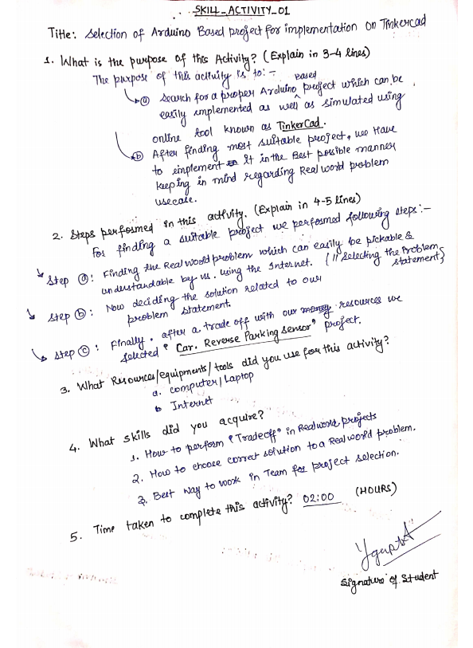

**(To be filled by Faculty)**

|  |  |  |
| --- | --- | --- |
| Sr. No. | Skill /Competencies | (Achieved / Not Achieved)  (Yes / No) |
|  |  |  |
|  |  |  |
|  |  |  |
|  |  |  |

Remarks :

Total mark ___________________________out of 10.

Signature of Faculty

Date: _________________

**Details of Activity:** 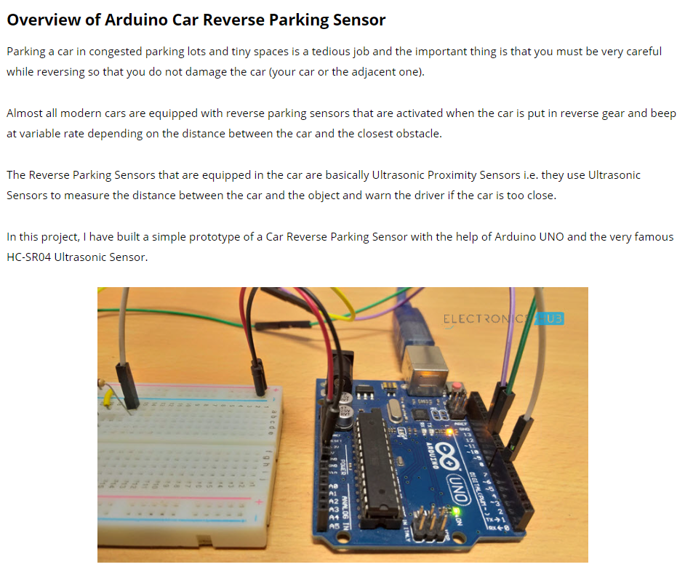  
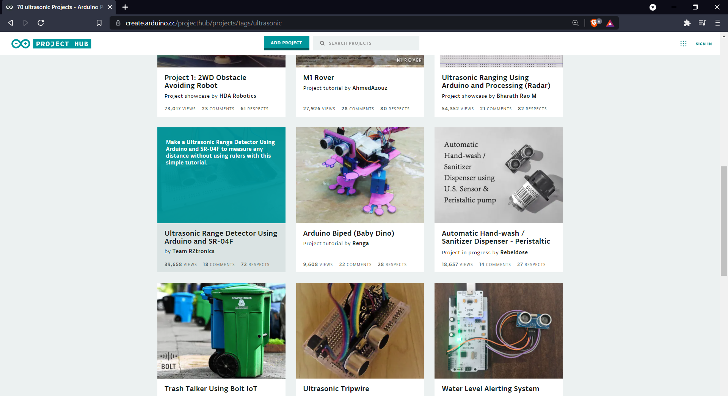

SKILL ACTIVITIY NO: 02  
(To be filled by the students)

Date: 04th September 2020

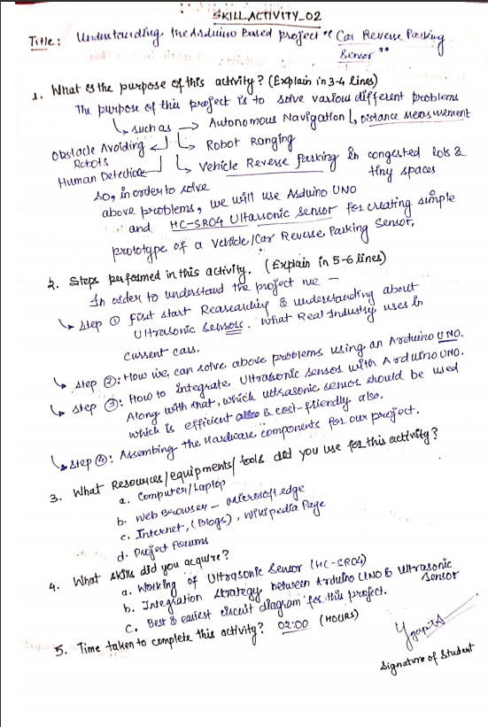

**(To be filled by Faculty)**

|  |  |  |
| --- | --- | --- |
| Sr. No. | Skill /Competencies | (Achieved / Not Achieved)  (Yes / No) |
|  |  |  |
|  |  |  |
|  |  |  |
|  |  |  |

Remarks :

Total mark ___________________________out of 10.

Signature of Faculty

Date: _________________

**Details of Activity:**

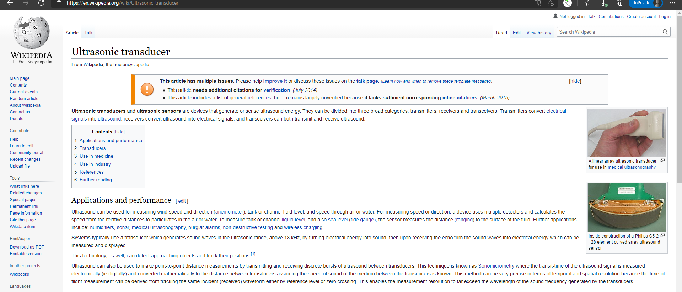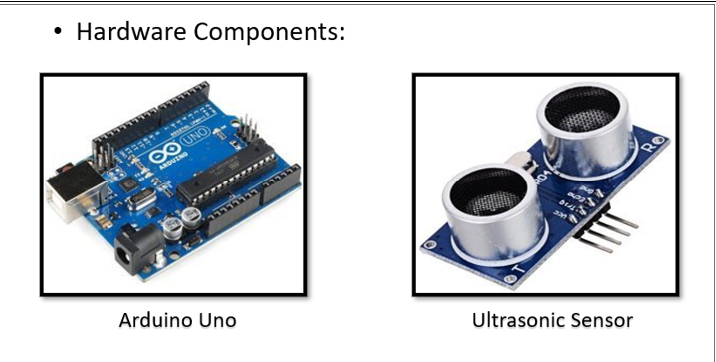

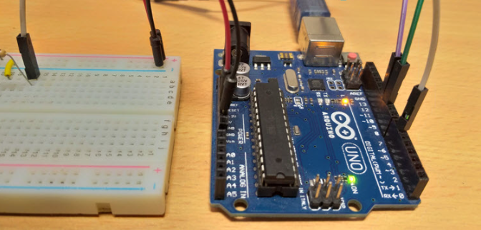  
  
  
  
  
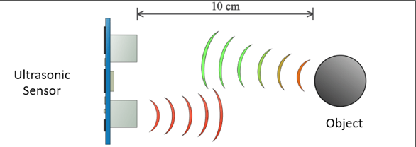

SKILL ACTIVITIY NO: 03  
(To be filled by the students)

Date: 11th September 2020

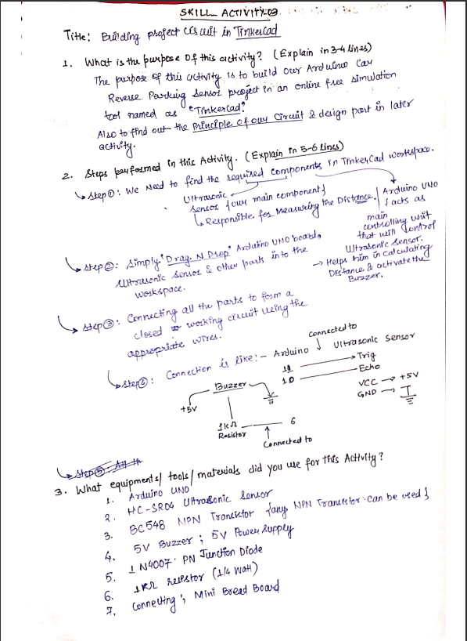

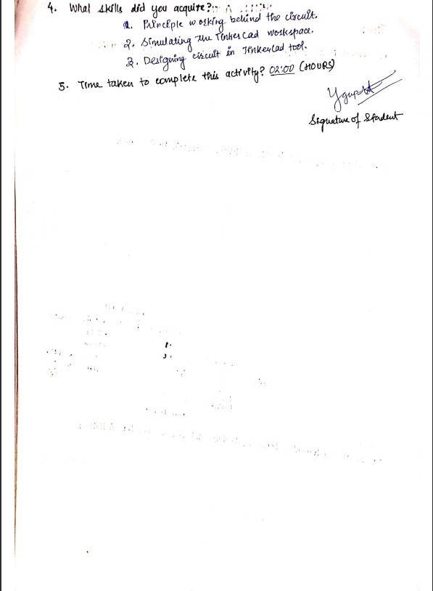

**(To be filled by Faculty)**

|  |  |  |
| --- | --- | --- |
| Sr. No. | Skill /Competencies | (Achieved / Not Achieved)  (Yes / No) |
|  |  |  |
|  |  |  |
|  |  |  |
|  |  |  |

Remarks :

Total mark ___________________________out of 10.

Signature of Faculty

Date: _________________

**Details of the Activity**

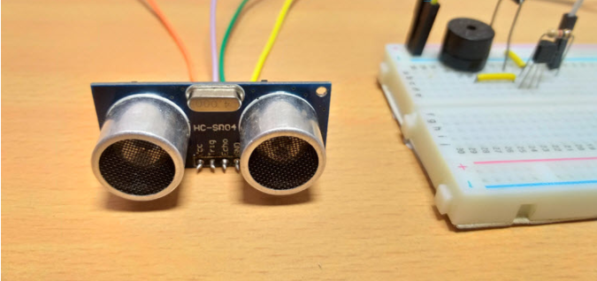

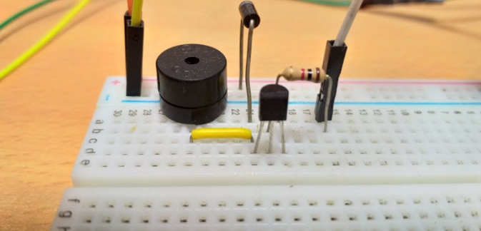

SKILL ACTIVITIY NO: 04  
(To be filled by the students)

Date: 18th September 2020

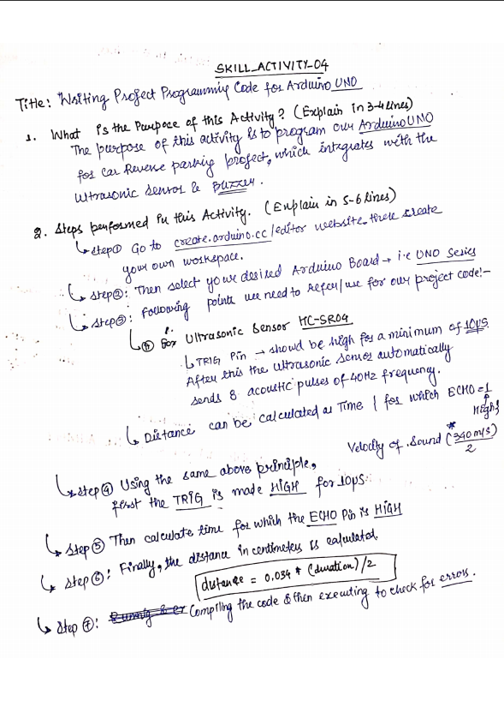

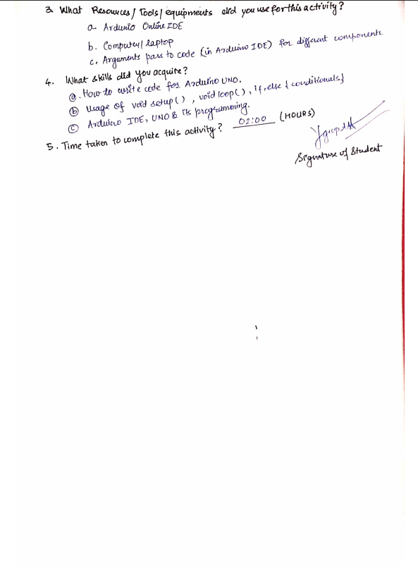

**(To be filled by Faculty)**

|  |  |  |
| --- | --- | --- |
| Sr. No. | Skill /Competencies | (Achieved / Not Achieved)  (Yes / No) |
|  |  |  |
|  |  |  |
|  |  |  |
|  |  |  |

Remarks :

Total mark ___________________________out of 10.

Signature of Faculty

Date: _________________

**Details of Activity:**



SKILL ACTIVITIY NO: 05  
(To be filled by the students)

Date: 25th September 2020  
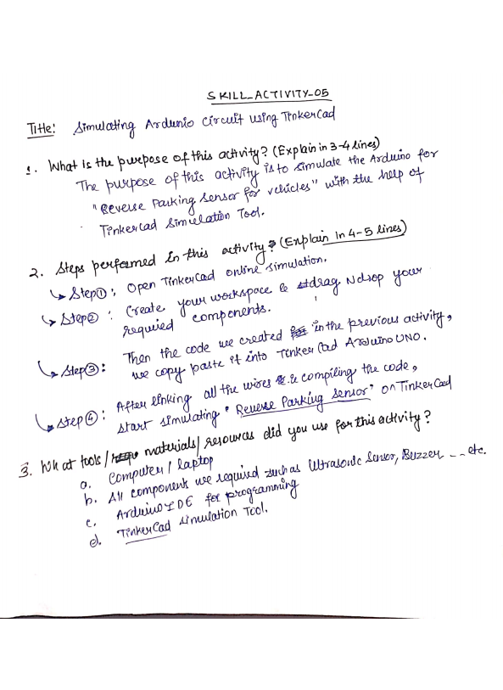

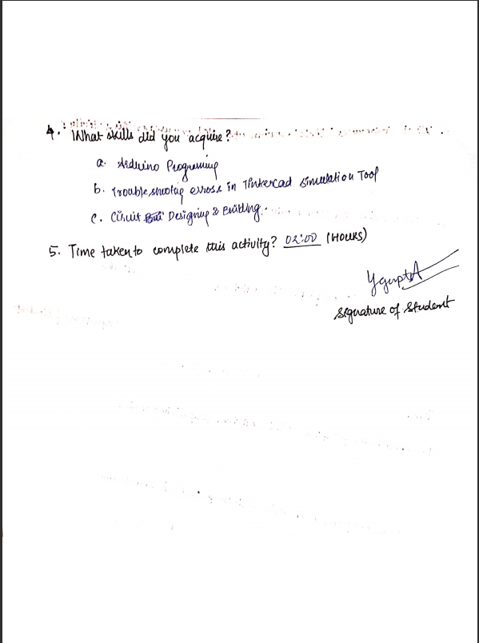

**(To be filled by Faculty)**

|  |  |  |
| --- | --- | --- |
| Sr. No. | Skill /Competencies | (Achieved / Not Achieved)  (Yes / No) |
|  |  |  |
|  |  |  |
|  |  |  |
|  |  |  |

Remarks:

Total mark ___________________________out of 10.

Signature of Faculty

Date: _________________

**Details of Activity:**

